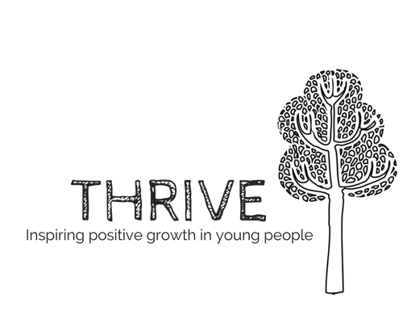
INFORMATION PACK, THRIVE RESIDENTIAL 1st – 3rd August 2022
Dear Parent/Guardians,
This year, Thrive will be running a summer residential for young people associated with our programmes. The residential will have a Christian focus and will be an opportunity to get away, spend some fun time together, meet new people and hear about the Christian faith. You will find all the information that you need in this letter, but please do not hesitate to get in touch if you have any questions.
Key Information:
Dates: Monday 1st August 3:30pm– Wednesday 3rd August 12:30pm
Location: RSPB Fen Drayton Lakes, Fen Drayton Rd, Cambridge CB24 4RB
Please note: the campsite will be cordoned off from the public, however, public may be able to access premises nearby. All leaders have been DBS checked and comply with our safeguarding policy. The surrounding areas are out of bounds and all young people will be asked not to venture off site/out of the bounds of the campsite unless supervised by a leader.

Cost: £25 to cover food and activity costs etc.
We have tried to keep the cost as low as possible. Please speak to a member of our team about further subsidies if this would be helpful for you.
How to get there: the location is just off Busway B at stop ‘The Busway Fen Drayton Lakes’ so we will organise for a group to travel there together. If you would like our leaders to escort your child to the campsite, we will be meeting at St Barnabas Church, Medway Road, Huntingdon PE29 1SF at 2:30pm on Monday 1st August and dropping off at around 12:30pm on Wednesday 3rd August. If you plan to drop your child off at the campsite yourself, please email sarah@thriveyouthwork.com to let her know.
RSVP: Please complete this form and return it to a Thrive team member before the 22nd July. You can also email return via email to sarah@thriveyouthwork.com
What to bring:
- Clothes for three days - Toothbrush, toothpaste, cleaning wipes
- One set of clothes that can get dirty - Walking shoes
- Pyjamas - Sleeping bag, roll mat, pillow
- Water bottle - Torch
- A jumper/waterproof jacket - Plate, cup, bowl, knife, fork, spoon
- Camping chair - Portable charger and mobile phone
If you do no not have any of the items, please let us know and we can help provide the necessities.
Additional Information
This residential will include a trip to Crazy Golf Tivoli and some time spent in Cambridge. This will involve getting the Busway B into Cambridge as a group where at least three leaders will be present at all times.
This residential will include an explanation of Christian faith. All young people are welcome, regardless of faith or background, and are welcome to share their perspectives. If you would like more information, please speak to a member of our team.
Please note that there are no showers at the campsite so please be sure to wash before the trip. Also, there is no electricity so please be sure to bring a battery pack to keep your phone charged.
Contact us:
For more information, please contact Sarah Gosling at sarah@thriveyouthwork.com or Ruth Hunt on 07458 305261.

